**Week 1 Assignment**

**Exercise 1: Implementing the Singleton Pattern**

**Scenario:**

You need to ensure that a logging utility class in your application has only one instance throughout the application lifecycle to ensure consistent logging.

**Steps:**

1. **Create a New Java Project:**
   * Create a new Java project named SingletonPatternExample.
2. **Define a Singleton Class:**
   * Create a class named Logger that has a private static instance of itself.
   * Ensure the constructor of Logger is private.
   * Provide a public static method to get the instance of the Logger class.
3. **Implement the Singleton Pattern:**
   * Write code to ensure that the Logger class follows the Singleton design pattern.
4. **Test the Singleton Implementation:**
   * Create a test class to verify that only one instance of Logger is created and used across the application.

**Solution**

**Logger.java**   
  
public class Logger {

    private static Logger instance;

    private Logger() {

        System.out.println("Logger instance created.");

    }

    public static Logger getInstance() {

        if (instance == null) {

            instance = new Logger();

        }

        return instance;

    }

    public void log(String message) {

        System.out.println("Log: " + message);

    }

}

**TestSingleton.java**

public class TestSingleton {

    public static void main(String[] args) {

        Logger logger1 = Logger.getInstance();

        Logger logger2 = Logger.getInstance();

        logger1.log("This is the first log message.");

        logger2.log("This is the second log message.");

        if (logger1 == logger2) {

            System.out.println("One instance of Logger exists.");

        } else {

            System.out.println("Multiple instances of Logger exist.");

        }

    }

}

**Output**

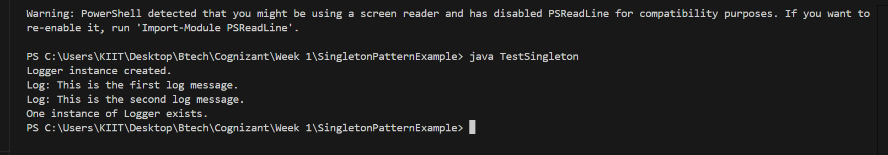

**Exercise 2: Implementing the Factory Method Pattern**

**Scenario:**

You are developing a document management system that needs to create different types of documents (e.g., Word, PDF, Excel). Use the Factory Method Pattern to achieve this.

**Steps:**

1. **Create a New Java Project:**
   * Create a new Java project named **FactoryMethodPatternExample**.
2. **Define Document Classes:**
   * Create interfaces or abstract classes for different document types such as **WordDocument**, **PdfDocument**, and **ExcelDocument**.
3. **Create Concrete Document Classes:**
   * Implement concrete classes for each document type that implements or extends the above interfaces or abstract classes.
4. **Implement the Factory Method:**
   * Create an abstract class **DocumentFactory** with a method **createDocument()**.
   * Create concrete factory classes for each document type that extends DocumentFactory and implements the **createDocument()** method.
5. **Test the Factory Method Implementation:**
   * Create a test class to demonstrate the creation of different document types using the factory method.

**Solution**

**Document.java**

public interface Document {

    void open();

}

**DocumentFactory.java**

public abstract class DocumentFactory {

    public abstract Document createDocument();

}

**ExcelDocument.java**

public class ExcelDocument implements Document {

    public void open() {

        System.out.println("Opening Excel document.");

    }

}

**ExcelDocumentFactory.java**

public class ExcelDocumentFactory extends DocumentFactory {

    public Document createDocument() {

        return new ExcelDocument();

    }

}

**PdfDocument.java**

public class PdfDocument implements Document {

    public void open() {

        System.out.println("Opening PDF document.");

    }

}

**PdfDocumentFactory.java**

public class PdfDocumentFactory extends DocumentFactory {

    public Document createDocument() {

        return new PdfDocument();

    }

}

**WordDocument.java**

public class WordDocument implements Document {

    public void open() {

        System.out.println("Opening Word document.");

    }

}

**WordDocumentFactory.java**

public class WordDocumentFactory extends DocumentFactory {

    public Document createDocument() {

        return new WordDocument();

    }

}

**FactoryTest.java**

public class FactoryTest {

    public static void main(String[] args) {

        DocumentFactory wordFactory = new WordDocumentFactory();

        Document wordDoc = wordFactory.createDocument();

        wordDoc.open();

        DocumentFactory pdfFactory = new PdfDocumentFactory();

        Document pdfDoc = pdfFactory.createDocument();

        pdfDoc.open();

        DocumentFactory excelFactory = new ExcelDocumentFactory();

        Document excelDoc = excelFactory.createDocument();

        excelDoc.open();

    }

}

**Output**

**Name:** Sanak Aich Bhowmick  
**Email:** 22051190@kiit.ac.in